Kamil Káčer 211777









**Normal mode:**

Counting direction is always up overruns when passes the last bit

**CTC mode:**

Allows greater controf of the compare match output frequency. Counting external events.

The counter value increases until compare match occurs between TCNT0 and OCR0A then counter is cleared (interrupt can be enabled)

**PWM mode:**

In PWM mode counter is incremented until the counter value matches the top value. Counter is cleared in the next cycle.

Two modes- non-inverting compare output mode and inverting compare output mode.

**Phase correct PWM mod**e

Counts until the counter value reatches top then it changes the counter direction

Interrupt flag can be used to generate interrupt each time the counter reaches the bottom.

Funkcia musí byt explicitne zavolaná kdežto ISR je zavolaná na základe nejakého externej udalosti. Keď je zavolaný napríklad interrupt tak sa zapíše do pamäti čo sa vykonávalo a prejde sa rovno na tú danú interrupciu.

Main c.

/***********************************************************************

*

* Control LEDs using functions from GPIO and Timer libraries. Do not

* use delay library any more.

* ATmega328P (Arduino Uno), 16 MHz, AVR 8-bit Toolchain 3.6.2

*

* Copyright (c) 2018-2020 Tomas Fryza

* Dept. of Radio Electronics, Brno University of Technology, Czechia

* This work is licensed under the terms of the MIT license.

*

**********************************************************************/

/* Defines -----------------------------------------------------------*/

#define LED_D1 PB5

#define LED_D2 PB4

#define LED_D3 PB3

/* Includes ----------------------------------------------------------*/

#include <avr/io.h> // AVR device-specific IO definitions

#include <avr/interrupt.h> // Interrupts standard C library for AVR-GCC

#include "gpio.h" // GPIO library for AVR-GCC

#include "timer.h" // Timer library for AVR-GCC

/* Function definitions ----------------------------------------------*/

/**

* Main function where the program execution begins. Toggle three LEDs

* on Multi-function shield with internal 8- and 16-bit timer modules.

*/

int main(void)

{

/* Configuration of three LEDs */

GPIO_config_output(&DDRB, LED_D2);

GPIO_write_low(&PORTB, LED_D2);

GPIO_config_output(&DDRB, LED_D1);

GPIO_write_low(&PORTB, LED_D1);

GPIO_config_output(&DDRB, LED_D3);

GPIO_write_low(&PORTB, LED_D3);

/* Configuration of 8-bit Timer/Counter0 */

TIM0_overflow_16ms();

TIM0_overflow_interrupt_enable();

/* Configuration of 16-bit Timer/Counter1

* Set prescaler and enable overflow interrupt */

TIM1_overflow_1s();

TIM1_overflow_interrupt_enable();

/* Configuration of 8-bit Timer/Counter2 */

TIM2_overflow_128us();

TIM2_overflow_interrupt_enable();

// Enables interrupts by setting the global interrupt mask

sei();

// Infinite loop

while (1)

{

/* Empty loop. All subsequent operations are performed exclusively

* inside interrupt service routines ISRs */

}

// Will never reach this

return 0;

}

/* Interrupt service routines ----------------------------------------*/

/**

* ISR starts when Timer/Counter1 overflows. Toggle LEDs on

* Multi-function shield. */

ISR(TIMER0_OVF_vect)

{

GPIO_toggle(&PORTB, LED_D1);

}

ISR(TIMER1_OVF_vect)

{

GPIO_toggle(&PORTB, LED_D2);

}

ISR(TIMER2_OVF_vect)

{

GPIO_toggle(&PORTB, LED_D3);

}

TIMER_H

#ifndef TIMER_H

#define TIMER_H

/***********************************************************************

*

* Timer library for AVR-GCC.

* ATmega328P (Arduino Uno), 16 MHz, AVR 8-bit Toolchain 3.6.2

*

* Copyright (c) 2019-2020 Tomas Fryza

* Dept. of Radio Electronics, Brno University of Technology, Czechia

* This work is licensed under the terms of the MIT license.

*

**********************************************************************/

/**

* @file timer.h

* @brief Timer library for AVR-GCC.

*

* @details

* The library contains macros for controlling the timer modules.

*

* @note

* Based on Microchip Atmel ATmega328P manual and no source file is

* needed for the library.

*

* @copyright (c) 2019-2020 Tomas Fryza

* Dept. of Radio Electronics, Brno University of Technology, Czechia

* This work is licensed under the terms of the MIT license.

*/

/* Includes ----------------------------------------------------------*/

#include <avr/io.h>

/* Defines -----------------------------------------------------------*/

/**

* @brief Defines prescaler CPU frequency values for Timer/Counter0.

* @note F_CPU = 16 MHz

*/

#define TIM0_stop() TCCR0B &= ~((1<<CS02) | (1<<CS01) | (1<<CS00));

#define TIM0_overflow_16us() TCCR0B &= ~((1<<CS2) | (1<<CS01)); TCCR0B |= (1<<CS00);

#define TIM0_overflow_128us() TCCR0B &= ~((1<<CS02) | (1<<CS00)); TCCR0B |= (1<<CS01);

#define TIM0_overflow_1ms() TCCR0B &= ~(1<<CS02); TCCR0B |= (1<<CS01) | (1<<CS00);

#define TIM0_overflow_4ms() TCCR0B &= ~((1<<CS01) | (1<<CS00)); TCCR0B |= (1<<CS02);

#define TIM0_overflow_16ms() TCCR0B &= ~(1<<CS01); TCCR0B |= (1<<CS02) | (1<<CS00);

/**

* @brief Defines prescaler CPU frequency values for Timer/Counter1.

* @note F_CPU = 16 MHz

*/

#define TIM1_stop() TCCR1B &= ~((1<<CS12) | (1<<CS11) | (1<<CS10));

#define TIM1_overflow_4ms() TCCR1B &= ~((1<<CS12) | (1<<CS11)); TCCR1B |= (1<<CS10);

#define TIM1_overflow_33ms() TCCR1B &= ~((1<<CS12) | (1<<CS10)); TCCR1B |= (1<<CS11);

#define TIM1_overflow_262ms() TCCR1B &= ~(1<<CS12); TCCR1B |= (1<<CS11) | (1<<CS10);

#define TIM1_overflow_1s() TCCR1B &= ~((1<<CS11) | (1<<CS10)); TCCR1B |= (1<<CS12);

#define TIM1_overflow_4s() TCCR1B &= ~(1<<CS11); TCCR1B |= (1<<CS12) | (1<<CS10);

/**

* @brief Defines prescaler CPU frequency values for Timer/Counter2.

* @note F_CPU = 16 MHz

*/

#define TIM2_stop() TCCR2B &= ~((1<<CS22) | (1<<CS21) | (1<<CS20));

#define TIM2_overflow_16us() TCCR2B &= ~((1<<CS22) | (1<<CS21)); TCCR2B |= (1<<CS20);

#define TIM2_overflow_128us() TCCR2B &= ~((1<<CS22) | (1<<CS20)); TCCR2B |= (1<<CS21);

#define TIM2_overflow_512us() TCCR2B &= ~(1<<CS22); TCCR2B |= (1<<CS21) | (1<<CS20);

#define TIM2_overflow_1024us() TCCR2B &= ~((1<<CS21) | (1<<CS20)); TCCR2B |= (1<<CS22);

#define TIM2_overflow_2048us() TCCR2B &= ~(1<<CS21); TCCR2B |= (1<<CS22) | (1<<CS20);

#define TIM2_overflow_4ms() TCCR2B &= ~(1<<CS20); TCCR2B |= (1<<CS22) | (1<<CS21);

#define TIM2_overflow_16ms() TCCR2B &= ((1<<CS22) | (1<<CS20) | (1<<C21));

/**

* @brief Defines interrupt enable/disable modes for Timer/Counter0.

*/

#define TIM0_overflow_interrupt_enable() TIMSK0 |= (1<<TOIE0);

#define TIM0_overflow_interrupt_disable() TIMSK0 &= ~(1<<TOIE0);

/**

* @brief Defines interrupt enable/disable modes for Timer/Counter1.

*/

#define TIM1_overflow_interrupt_enable() TIMSK1 |= (1<<TOIE1);

#define TIM1_overflow_interrupt_disable() TIMSK1 &= ~(1<<TOIE1);

/**

* @brief Defines interrupt enable/disable modes for Timer/Counter1.

*/

#define TIM2_overflow_interrupt_enable() TIMSK2 |= (1<<TOIE2);

#define TIM2_overflow_interrupt_disable() TIMSK2 &= ~(1<<TOIE2);

#endif

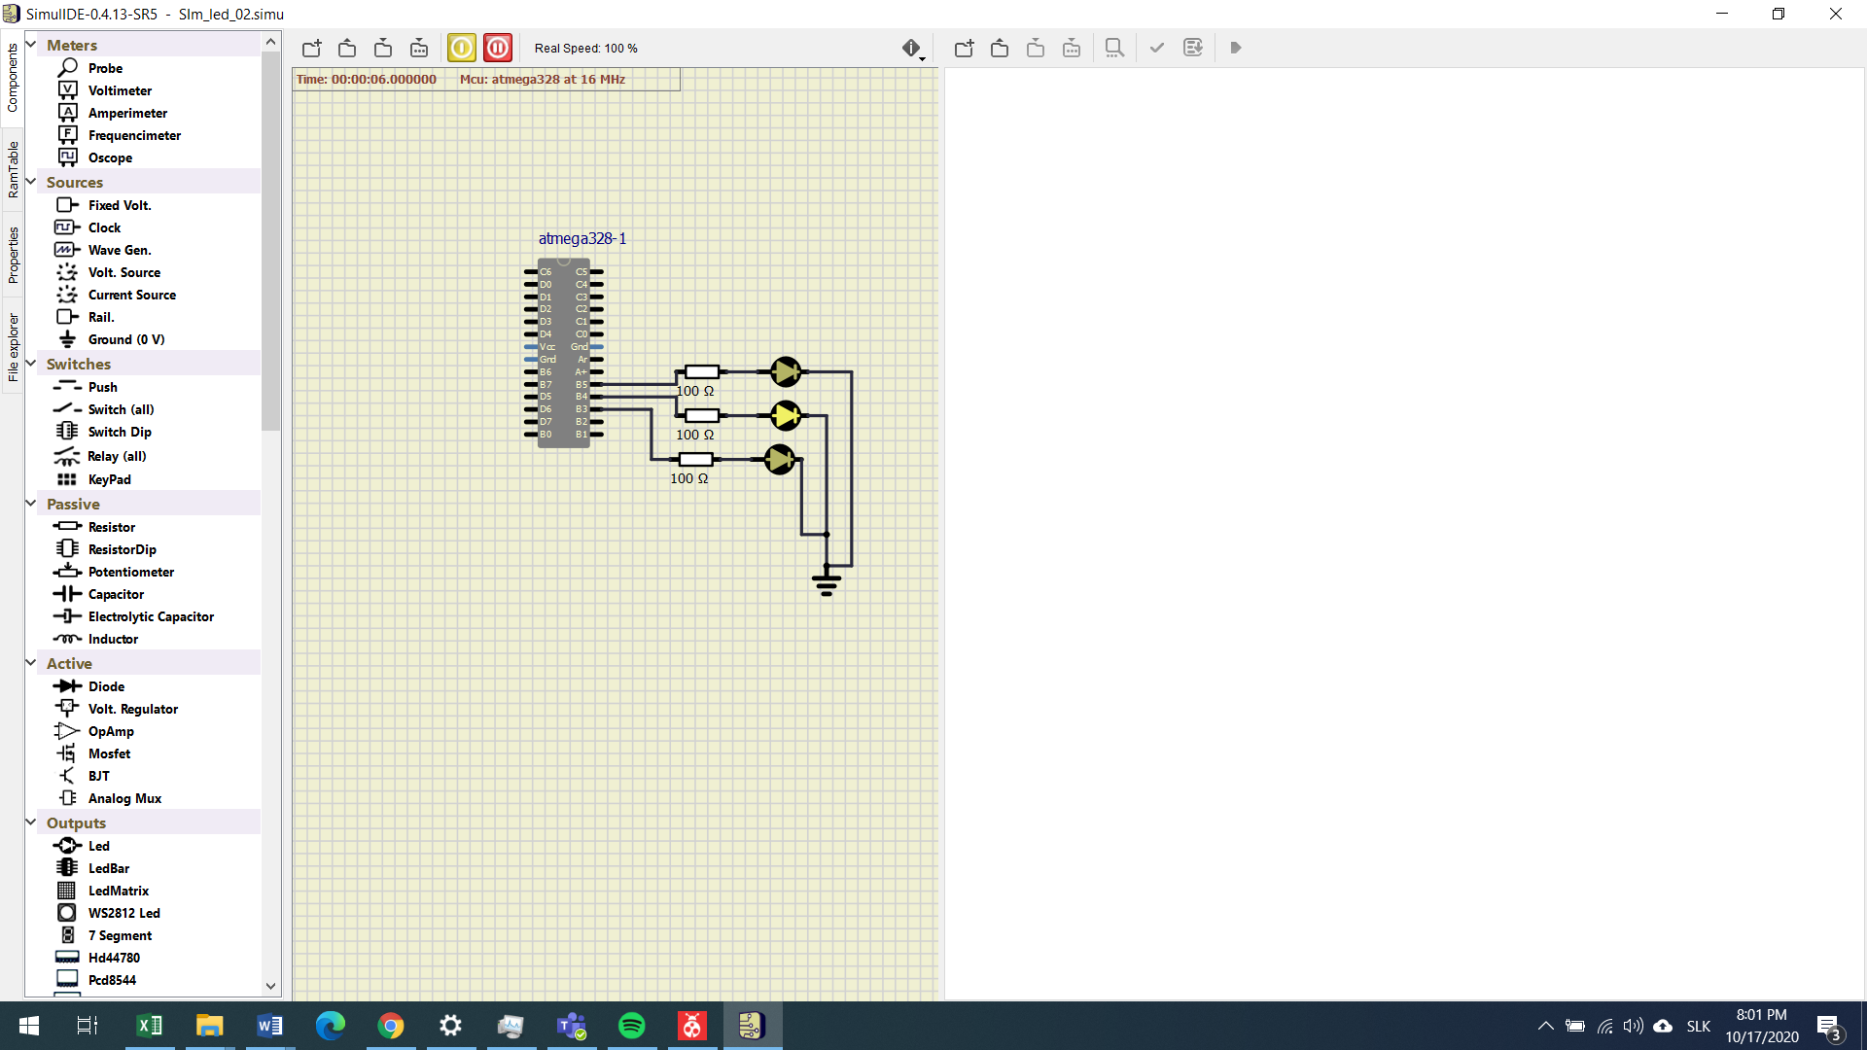

Cannot see two other leds blinking because prescalar is still too small for human eye to recognize its change.